Handout 1
C++ Programming
Deadline October 5

Exercise 1
Given the following assignment of variables to values:
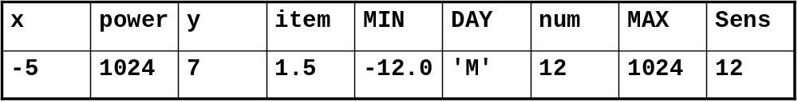

Fill in the result values of the conditions in the table below:

Condition | Result
(x>y) && !y | 0
(item>MIN)||(DAY!=’M’) | 1
((num*128)<power)&&y | 0
(!(power!=MAX))&&(Sens==num) | 1
((y+x)<num)||(DAY==’M’) | 1
(Sens*(!y))!=0 | 0
(!x||y)&&(!y||x) | 1

Exercise 2
Write a program in C++ that performs the following tasks:
- Read three integer values using cin.
- Determine the maximum of the three values entered by the user.
- Print the maximum of this three values using cout.

#include <iostream>
int main() {
int numbers[3] = {};
// array was not necessary here, I could just use 3 integer variables
std::cout << ">> Please enter a number (integer) ";
std::cin >> numbers[0];
std::cout << ">> Please enter a 2nd number ";
std::cin >> numbers[1];
std::cout << ">> Please enter a 3rd number ";
std::cin >> numbers[2];
int max = numbers[0];
if (numbers[0] > numbers[1] && numbers[0] > numbers[2])
max = numbers[0];
else if (numbers[1] > numbers[0] && numbers[1] > numbers[2])
max = numbers[1];
else if (numbers[2] > numbers[0] && numbers[2] > numbers[1])
max = numbers[2];
else
std::cout << "Something went wrong!!" << std::endl;
// another possible solution:
/*for (int number: numbers) {
if (number > max)
max = number;
}*/
std::cout << ">> The max is: " << max << std::endl;
return 0;
}

Exercise 3
Write a program that asks the user to type numbers. After each entry, the program should report the cumulative sum of the entries. The program should terminate when the user enters 0.

#include <iostream>
#include <list>
using namespace std;
int main() {
double sum = 0;
double newNum;
while (true) {
std::cout << ">> Please enter a number ";
std::cin >> newNum;
// if you enter something else then a number newNum will be 0
if (newNum == 0)
return 0;
sum += newNum;
std::cout << "The sum of the entries is: " << sum << std::endl;
}
// Or another alternative:
/*list<double> numbers = {};
double temp;
while (true) {
std::cout << ">> Please enter a number ";
std::cin >> temp;
if (!temp)
return 0;
numbers.push_back(temp);
double sum = 0;
for (auto number : numbers) {
sum += number;
}
std::cout << "The sum of the entries is: " << sum << std::endl;
}*/
}

Exercise 4
Create a program to determine the GCD (Greatest Common Divisor) of two integers x and y using a ‘while loop’.

Formal description of the Euclidean algorithm
- Input Two positive integers, a and b.
- Output The greatest common divisor, g, of a and b.
- Internal computation
  - If a<b, exchange a and b.
  - Divide a by b and get the remainder, r.
If r=0, report b as the GCD of a and b.
  - Replace a by b and replace b by r. Return to the previous step.
#include <iostream>
using namespace std;
class GCD {
public:
double getEntry() {
int entry;
std::cout << ">> Please enter a number ";
std::cin >> entry;
while (entry < 0) {
std::cout << "Invalid entry. Try again!" << std::endl;
std::cin >> entry;
}
return entry;
}
double getGCD(int a, int b) {
while(true){
if (a < b) {
int temp = a;
a = b;
b = temp;
}
int r = a % b;
if (r == 0)
return b;
a = b;
b = r;
}
// alternative using recursion
/*if (a < b) {
int temp = a;
a = b;
b = temp;
}
int r = a % b;
if (r == 0)
return b;
return getGCD(b, r);*/
}
};
int main() {
// creating an object/class wasn't necessary here,
// I just wanted to try it
GCD gcd_obj;
int a = gcd_obj.getEntry();
int b = gcd_obj.getEntry();
std::cout << "The gcd of " << a << " and " << b << " is " << gcd_obj.getGCD(a, b) << std::endl;
}

